Investigating fluid flows with 4D tomographic PIV

In the context of the IMATECBIO CPER (2015-2020), the research federation FERMAT (Fluids, Energy, Reactors, Materials and Transfers), composed of major laboratories in Toulouse, including IMFT is owning since recently a complete time resolved 3D Tomographic PIV & 3D tracking system. The Research Engineer/Post-doctoral position will be directly supervised by the “Signals and Images” service of IMFT. The objective is to perform measurements with this newly acquired and advanced metrological device, in collaboration with researchers of the laboratory, on various experiments: 3D dynamics of a particle settling near a wall in a viscoplastic fluid, wakes and vortex rings in a density stratified fluid, characterization of the 3D velocity field in the vicinity of bubbles and moving cylinders in a confined cell, analysis of the 3D flow around two Barkhane dunes.
Profile and skills: (PhD degree is required)

The candidate must have a PhD degree in fluid mechanics with a strong experimental and metrological background related to flow characterization using a tomographic PIV system. He/she will participate in the installation and implementation of the tomographic PIV measurement devices in order to characterize different kinds of flow configurations by adapting to experimental constraints (optical access, complex calibrations, seeding, optical constrain in multiphase flows ...) and will also need to develop pre/post processing tools dedicated to the results. He/she will carry out studies, in parallel, on different experimental projects and devices relating to various scientific topics (stratified fluids, fluid/ structure interactions, multiphase flows, etc.).

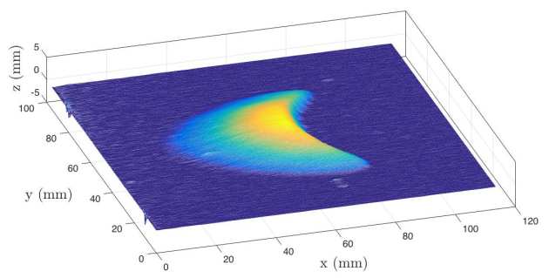
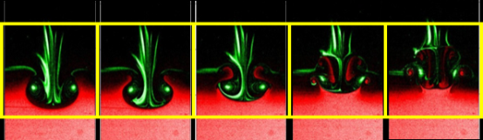
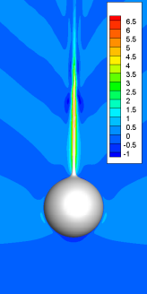

Keywords: Fluid mechanics, Tomographic PIV, Image processing, 3D data post-processing.
Research unit: Institute of Fluids Mechanics in Toulouse - http://www.imft.fr
The Fluids Mechanics Institute of Toulouse (IMFT) is a joint research laboratory between CNRS, INPT, UPS. IMFT gathers about 200 people, including 70 faculty members, 35 engineers, technicians and administrative staff, 70 PhD students and 20 post-docs. It represents one of the major laboratories in France and even in Europe in terms of research and advanced training in fluids dynamics, both by its size and by its wide range of scientific topics and applicative fields. The laboratory develops a broad range of research activities covering the fundamental aspects related to the physics of fluids and their mathematical description, as a vast field of applications.
Salary: 2100 Euros net /month - 12 months, starting date: November 2017

Application: Send CV, cover letter, recommendations / references, list of publications.

